Failed test cases

1. Failed to detect closed eyes.

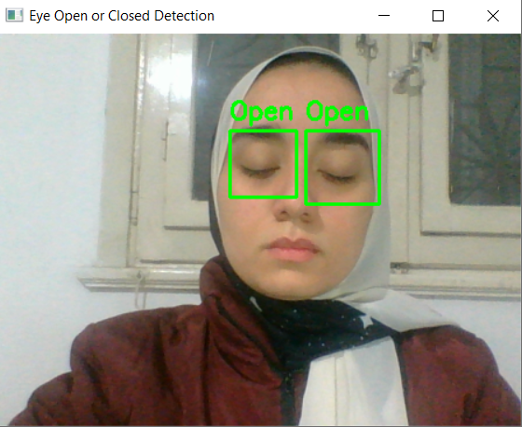

Another approach Failed to detect open eyes with wrong positioning of eye frame 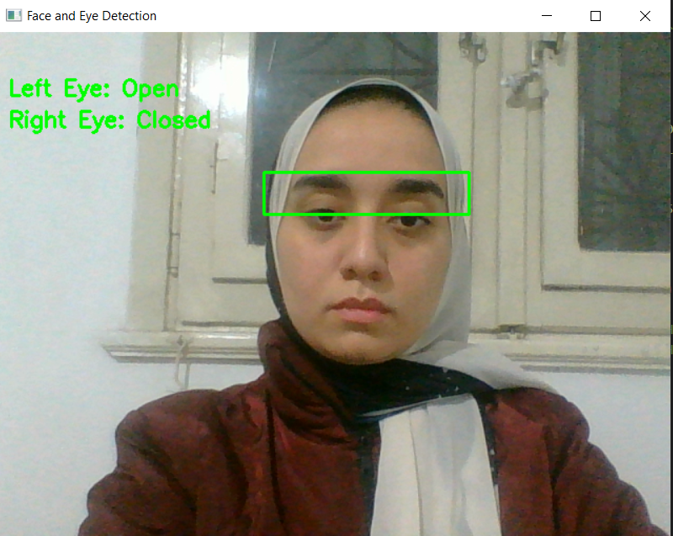

3-Failed to detect open eyes

